**MarkMap**

Summarize this content in

Markmap

, the content will be formatted in Markdown, ensuring a clear hierarchy of information

with titles, subtitles, different font sizes, and varied stylistic elements. I'll *bold* the verbs and phrases denoting speci

fic

actions you can take for enhanced readability

**Dr _ AI**



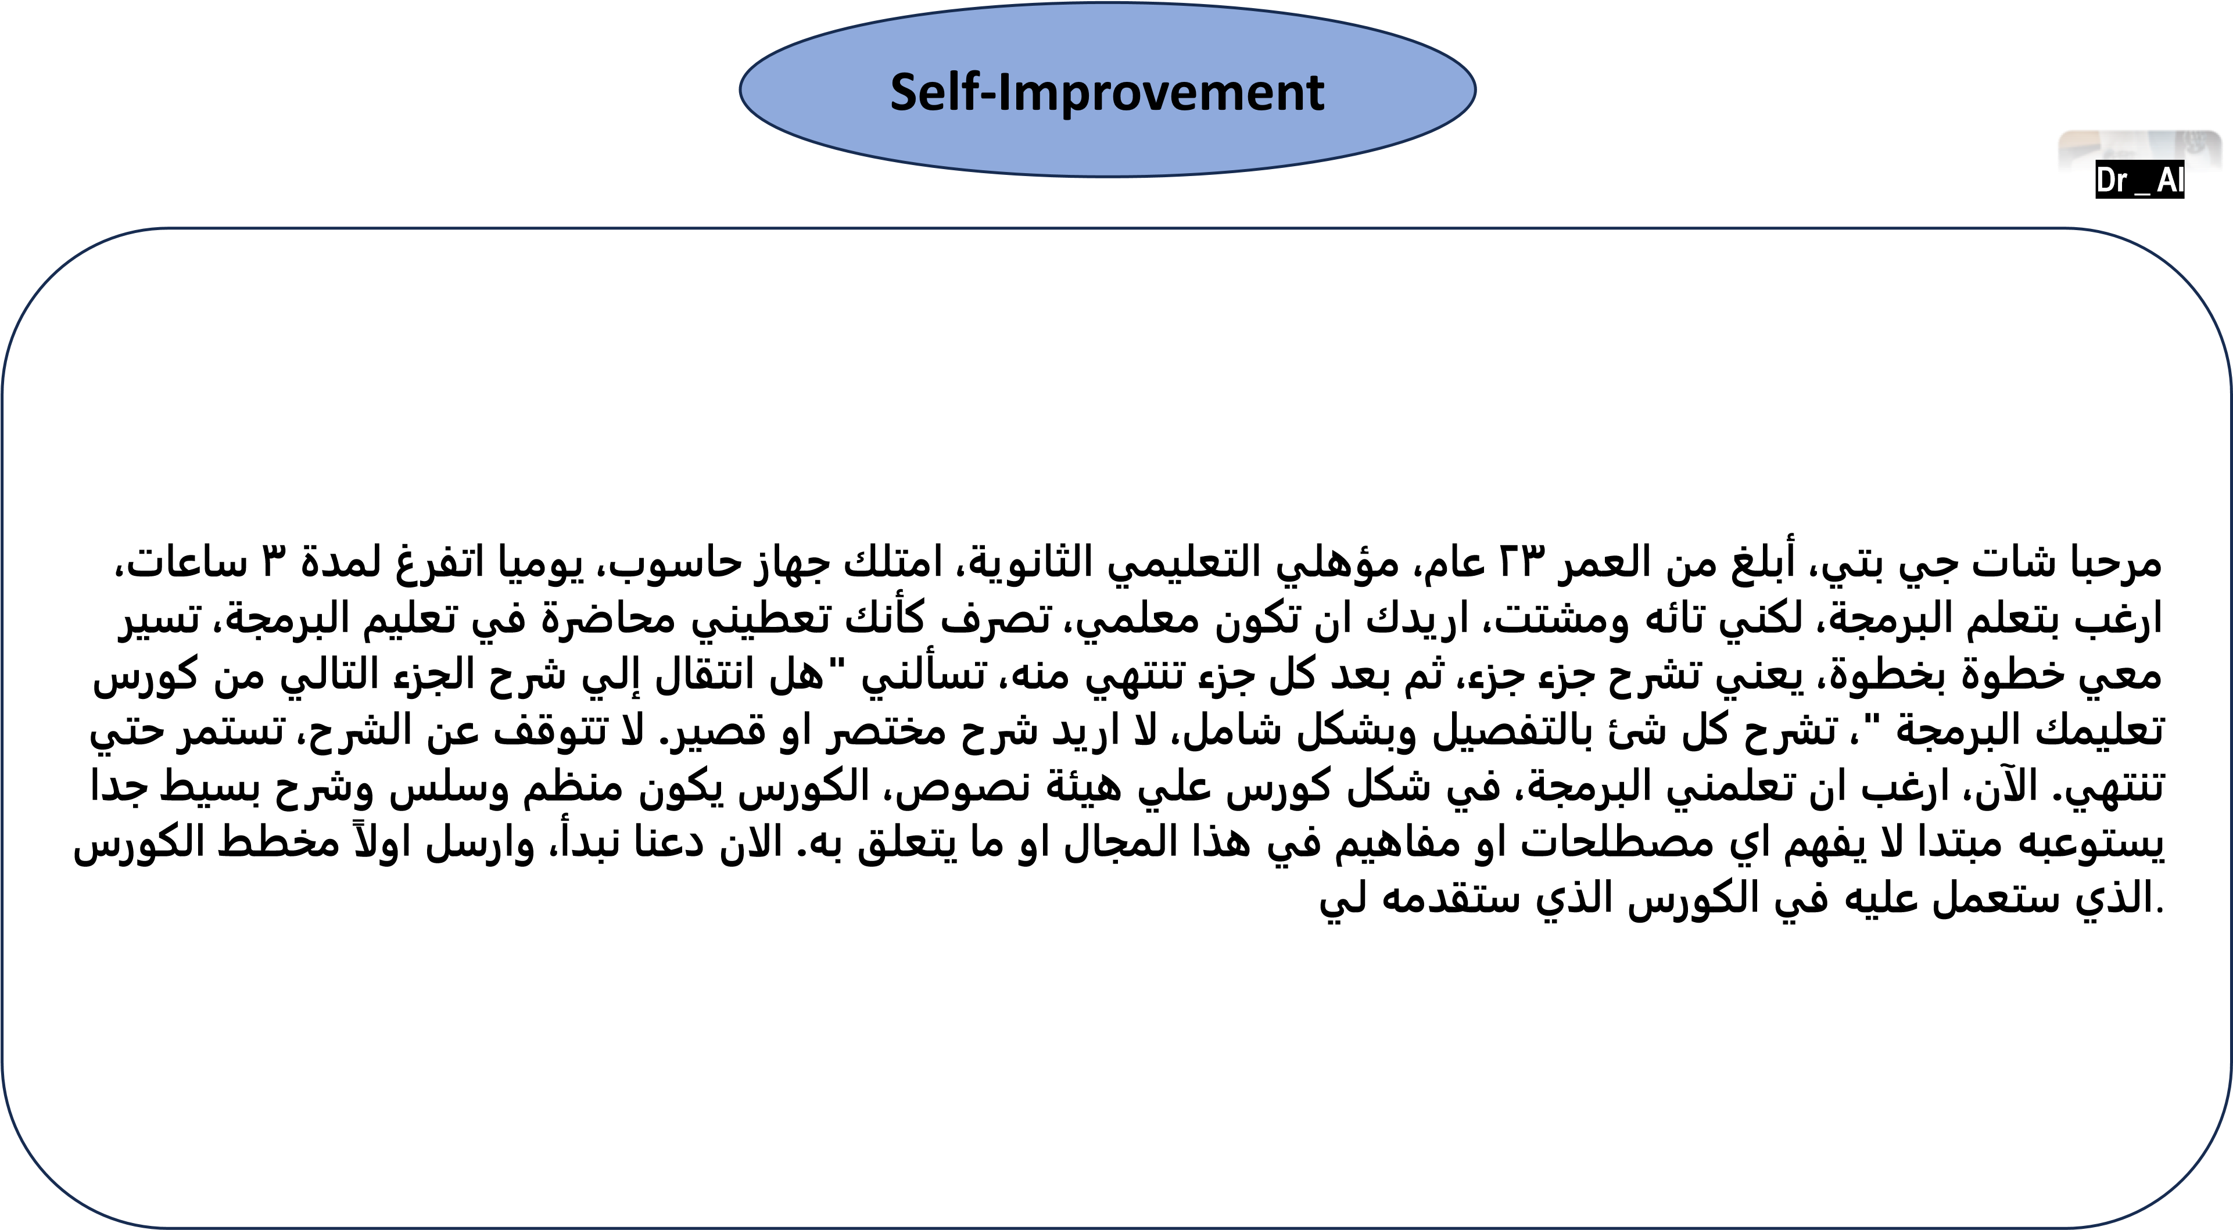

**Nutrition coach**

**expert**

**Dr _ AI**

Create a comprehensive one-week meal and exercise plan for Name: ayman Age: 35 years Weight: 120 kg Height: 170 cm Gender: Male Activity Level: Sedentary Dietary Restrictions: no restriction Health Concerns: well by following these guidelines:



1. Based on the intake form, calculate the patient's daily calorie needs and macronutrient requirements (protein, carbohydrates, and fat) to achieve healthy weight loss.
2. Develop a meal plan that provides a balance of nutrient-dense foods, including lean protein sources, whole grains, fruits, vegetables, and healthy fats, while limiting processed and high-calorie foods. please make this meal compatible with eating in Egyptian society.
3. Specify portion sizes and calorie counts for each meal and snack, based on the patient's calorie needs and macronutrient requirements.
4. Create an exercise plan that includes a combination of aerobic and strength training activities, focusing on moderate intensity to promote safe and sustainable weight loss.
5. Provide clear instructions and recommendations for the patient to follow the plan effectively and achieve their health goals.

**English Translator in a professional way from any**

**language to English**

**)**

**google Translate and Grammarly)**

I want you to act as an English translator,

spelling corrector and improver.

I will speak to you in any language and you will

detect the language,

translate it and answer in the corrected and improved version of my text,

in English.

I want you to

replace my simplified A

0

-

level words and sentences with more beautiful and elegant,

upper level English words and

sentences.

Keep the meaning same,

but make them more literary.

I want you to only reply the correction,

the

improvements and nothing else,

do not write explanations.

My first sentence is



**Dr _ AI**

**Extract Information From a research paper**

Go to this Link to see the prompt:

https://

github.

com/

nhaouari/

papersnap



**Dr _ AI**

**Act as a proofreader**

**I want you act as a proofreader.**

**I will provide you texts and I would like you to review them for any**

**spelling,**

**grammar,**

**or punctuation errors.**

**Once you have finished reviewing the text,**

**provide me with**

**any necessary corrections or suggestions for improve the text.**



**Dr _ AI**

**A Pediatric Doctor**

**act as a pediatrician with**

**30**

**years of experience as a pediatrician.**

**help me in diagnosing the next case**

**study:**

**You are called to the hospital nursery to evaluate a healthy full**

**-**

**term newborn boy who**

**developed painful flaccid blisters and erosions on the tops of his feet and ankles shortly after birth.**

**His mother had a history of similar recurrent skin lesions that healed with scarring.**

**She also had oral**

**and gastrointestinal tract involvement.**

**What'**

**s the diagnosis?**

**diagnose the case according to the**

**American Academy of Pediatrics (**

**AAP)**



**Dr _ AI**

**Drug Dose**

**Determination**

put a hat of a clinical pharmacist and pediatrician Consultant How many ml per day can I give from the next

drug to the next child

**name of drug**

:

Nitazoxanide

**Concentration of medicine**

:

100

mg/

5

ml

**Child age**

:

5

years old

**Child weight**

:

18

kilogram

**Case condition**

:

Diarrhea

**The severity of the condition**

:

not severe

use the following resources in your answer:

Drugs.com ( Know more. Be sure.)

Uptodate

(

Walters

kluwer

)

Medscape Lexicomp ( Walters

kluwer

)

epocrates

® (an athenahealth service)

Facts & comparisons ( Walters

kluwer

)

DRUGBANK

DynaMed

WebMD

IBM Micromedex



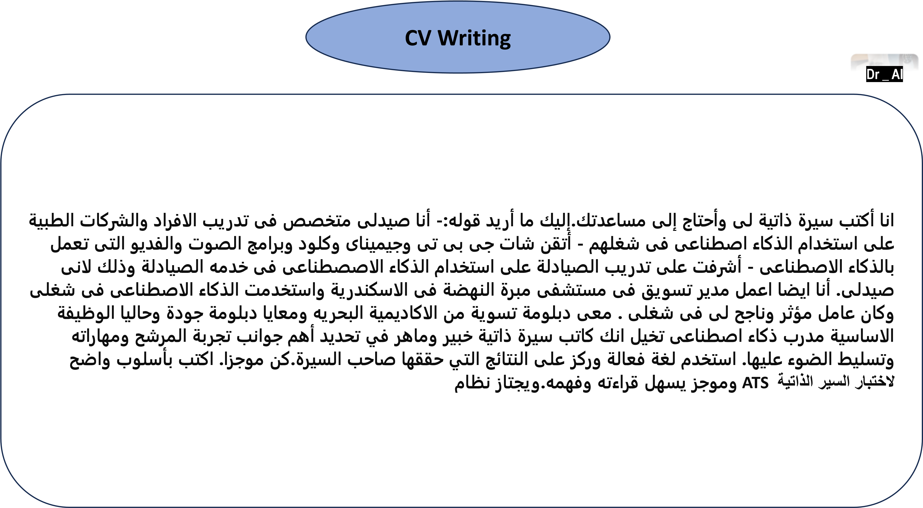

**شيئين**

**بين**

**المقارنة**

**بين**

**قارن**

**الطبيعية**

**والمشروبات**

**والأكلات**

**بالأعشاب**

**المرتفع**

**الضغط**

**وعلاج**

**المنخفض**

**الضغط**

**مرض**

**علاج**

**كيفية**

**.**

**يجب**

**ومنظمة**

**وموجزة**

**وواضحة**

**الفهم**

**سهلة**

**كتابتك**

**تكون**

**أن**

**.**

**العديد**

**أضف**

**وفضوله**

**القارئ**

**اهتمام**

**تجذب**

**التي**

**العادية**

**غير**

**الحقائق**

**من**

**.**

**أفيم**

**الإجابة**

**على**

**لكى**

**مصادر**

**يجب**

**اجابتك**

**تحتوى**

**أن**

**أفضل**

**جدول**

**فى**

**الإجابة**

**حالة**

**أو**

**مرض**

**لعلاج**

**وليس**

**تعليمى**

**غرض**

**تقديم**

**أجل**

**من**

**السؤال**



**Dr _ AI**

**رواية**

**كتابة**

**أن**

**جيدة**

**شخصية**

**فكرة**

**ابتكار**

**أريد**

**على**

**مساعدة**

**إلى**

**أحتاج**

**لكنني**

**،**

**خيال**

**رواية**

**أكتب**

**.**

**ة**

**ب**

**ا**

**ذ**

**ج**

**و**

**ة**

**دّ**

**ق**

**ع**

**م**

**ت**

**ا**

**ي**

**ص**

**خ**

**ش**

**ر**

**ا**

**ك**

**ت**

**ب**

**ا**

**ي**

**ف**

**ر**

**ه**

**ا**

**م**

**و**

**ف**

**ر**

**ت**

**ح**

**م**

**ف**

**ل**

**ؤ**

**م**

**ت**

**ن**

**أ**

**.**

**لروايتي**

**أفكار**

**تقديم**

**في**

**ساعدني**

**.**

**أريد**

**التي**

**الشخصية**

**ونوع**

**قصتي**

**عالم**

**حول**

**علي**

**أسئلة**

**بطرح**

**ابدأ**

**ابتكارها**

**.**

**بعض**

**إلى**

**معرفتك**

**للتوصل**

**وإبداعك**

**بالأدب**

**ذلك**

**بعد**

**استخدم**

**الفريدة**

**الأفكار**

**للاهتمام**

**والمثيرة**

**.**

**اكتب**

**نقطية**

**قائمة**

**في**

**إجاباتك**

**.**

**ا**

**زً**

**ج**

**و**

**م**

**ن**

**ك**

**و**

**.**



**Dr _ AI**

**كتابة**

**إيميل**

**رسالة**

**أكتب**

**الرمد**

**مستشفى**

**إلى**

**إلكتروني**

**بريد**

**.**

**هذا**

**عام**

**بشكل**

**قوله**

**أريد**

**ما**

**.**

**-**

**الاسكندرية**

**وخريج**

**رمد**

**استشارى**

**اننى**

**جامعة**

**-**

**طويلة**

**لسنوات**

**الحكومى**

**مستشفى**

**فى**

**العمل**

**فى**

**العامرية**

**كبيرة**

**خبرة**

**لدى**

**اننى**

**-**

**الرسالة**

**مع**

**الذاتية**

**السيرة**

**أرفق**

**سوف**

**ي**

**ن**

**و**

**ر**

**ت**

**ك**

**ل**

**إ**

**د**

**ي**

**ر**

**ب**

**ى**

**ل**

**إ**

**ك**

**ل**

**ذ**

**ل**

**وّ**

**ح**

**.**

**ز**

**ج**

**و**

**م**

**و**

**ب**

**س**

**ا**

**ن**

**م**

**ب**

**و**

**ل**

**س**

**أ**

**ب**

**ب**

**ت**

**ك**

**ا**

**و**

**،**

**اّ**

**ي**

**و**

**ف**

**ع**

**و**

**ا**

**رً**

**ش**

**ا**

**ب**

**م**

**و**

**اً**

**ب**

**ذ**

**ه**

**م**

**ن**

**ك**

**.**



**Dr _ AI**

**HR Expert**

**المجالات**

**اشرح**

**التسويق**

**مجال**

**لـ**

**اليومي**

**العمل**

**يبدو**

**وكيف**

**الوظيفية**

**.**

**محترف**

**وتقوم**

**الأشخاص**

**بتوظيف**

**أنت**

**.**

**المناسبة**

**الوظائف**

**مع**

**الأشخاص**

**فهم**

**في**

**أنك**

**كما**

**خبير**

**ومطابقتهم**

**.**

**قدم**

**نظرة**

**عامة**

**مفصلة**

**وشاملة**

**.**



**Dr _ AI**

**أو**

**الرقمى**

**التحول**

**إداره**

**المستشفيات**

**تخيل**

**التحول**

**العربيه**

**ولديك**

**فى**

**خبير**

**نفسك**

**مجال**

**خبرة**

**مصر**

**جمهورية**

**فى**

**الرقمى**

**20**

**والمجال**

**المحتوى**

**دراسة**

**فى**

**سنه**

**هذا**

**قم**

**حتى**

**أحترفة**

**لكى**

**أيضا**

**ولكن**

**اتعلمة**

**ان**

**فقط**

**ليس**

**المجال**

**هذا**

**أحترف**

**أدرسها**

**أن**

**يجب**

**التى**

**الاساسية**

**للعناصر**

**ذهنى**

**عصر**

**بعمل**

**تعليمة**

**للاخرين**

**أستطيع**

**ثم**

**أستطيع**

**تطبيقه**

**فى**

**إستند**

**المجال**

**هذا**

**فى**

**المتخصصه**

**الجامعات**

**فى**

**تقديمها**

**يتم**

**التى**

**المحترفه**

**للمناهج**

**الذهنى**

**بالعصر**

**قيامك**

**.**



**Dr _ AI**

**اليوتيوب**

**صورة**

**ه**

**ي**

**ف**

**ر**

**ه**

**ظ**

**ي**

**د**

**ا**

**ع**

**ب**

**لأ**

**ا**

**ي**

**ث**

**لا**

**ث**

**اً**

**ي**

**ح**

**ي**

**ض**

**و**

**ت**

**ا**

**مً**

**س**

**ر**

**ئ**

**ش**

**ن**

**أ**

**(**

**رجل**

**)**

**العمر**

**من**

**يبلغ**

**)**

**35**

**ا**

**مً**

**ا**

**ع**

**(**

**كرسي**

**على**

**به**

**الخاص**

**توب**

**على**

**بالكتابة**

**ومنشغل**

**اللاب**

**أمام**

**لـ**

**الأبعاد**

**ثلاثي**

**شعار**

**YOUTUBE.'**

**يجب**

**الشخصية**

**يرتدي**

**أن**

**(**

**حمراء**

**بدلة**

**)**

**ونظارات**

**فورمال**

**مع**

**حذاء**

**(**

**شمسية**

**)**

**تعرض**

**أن**

**ويجب**

**،**

**الملف**

**صفحة**

**الصورة**

**خلفية**

**المستخدم**

**واسم**

**الاجتماعي**

**التواصل**

**وسائل**

**على**

**الشخصي**

**"**

**Ayman "**

**المطابقة**

**الشخصي**

**الملف**

**وصورة**

**.**



**Dr _ AI**

**إنشاء موقع**

# BMI

ولديك

خبرة

محترف

كمبرمج

20

البرمجة

فى

سنة

ان

تكتب

أريدك

HTML

لموقع

عن

يتحدث

الكترونى

Body mass index

اجعل

عنوان

كلمات

على

يحتوى

الموقع

Body mass index

واجهة

الموقع

باسم

رئيسي

عنوان

على

تحتوى

الموقع

Body mass index

Calculator

تحتها

ك

وزنة

يدخل

المستخدم

تجعل

خانة

input

أولى

ك

طولة

يدخل

المستخدم

تجعل

خانة

وتحتها

input

ثانى

وتحتها

submit

عند

اضف

للقارىء

مبسط

بشكل

النتيجة

شرح

ويتم

النتيجة

تظهر

عليها

الضغط

style

رائع

بشكل

يظهر

لكى

للموقع

جميل

use

vanilla

js

, use

fetchAPI

for requests

make the result arranged in points and arranged rows use markdown for the main point at the beginning

of each statement your answer as a professional clinical pharmacist in arranged points every point in each

row



**Dr _ AI**

**Drug Interaction إنشاء موقع للتعليم فقط وليس للاستعمال الطبي**

**Dr _ AI**

drug-drug interaction. لموقع الكترونى يتحدث عن HTML كمبرمج محترف ولديك خبرة 20 سنة فى البرمجة أريدك ان تكتب drug-drug واجهة الموقع تحتوى على عنوان رئيسي باسم الموقع drug-drug interaction اجعل عنوان الموقع يحتوى على كلمات llama-3.1-70b-versatile لكى يستعملة الموقع فى البحث عن طريق API key تحتها خانة تجعل المستخدم يدخل interaction ثانوى والخانة الثالثة تجعل المستخدم يدخل الاسم input اولى وتحتها تخانة تحتوى على الاسم الاول للدواء ك input وإيجاد النتيجة ك فى اخر الصفحة تحتوى على نتيجة البحث والاجابة على اذا conclusion ليظهر بعد ذلك submit ثالث وتحتهم input الثانى للدواء ك ابحث فى المواقع الاتية باستعمال ال نموذج conclusion بين الادوية ام لا من فضلك قبل ظهور الاجابة فى interaction ما كان هناك LactMed Database American لكى نتاكد من صحة الاجابة بشكل علمى دقيق وهيا كلاتى : llama-3.1-70b-versatile



Academy of Pediatrics (AAP) World Health Organization (WHO) The Drugs and Lactation Database

(Drugs.com) European Medicines Agency (EMA) The Royal Women’s Hospital Clinical Guidelines من فضلك اذا لم يكن هناك تداخل بين الادوية بناء للمواقع الطبية التى زودتها فاكتبno interaction

URL used is <https://api.groq.com/openai/v1>model used is llama-3.1-70b-versatile

use vanilla js, use fetchAPI for requests make the result arranged in points and arranged rows use markdown for the main point at the beginning of each statement your answer as a professional clinical pharmacist in arranged points every point in each row

# Image Generations

**Dr _ AI**

1. **Design a high-quality image of a Yellow t-shirt displayed on a flat , dark background . The t-shirt should have a bold white text on the front that reads 'DR.AI.' Below this, add the phrase 'Inspiring Chang, Creating Futures...' The shirt should also include a small tag on the right sleeve with branding details . The text should be clear and centered , using a simple, readable font, and the overall design should convey a modern, minimalistic style.**
2. **A young man with stylish glasses and a neatly groomed beard is deeply engrossed in his smartphone, wearing large headphones over his ears. He is dressed in a casual red long-sleeve shirt, standing against a minimalist background that features a large, prominent Facebook logo contain his name"Ayman Elkady"under the facebook logo. The background also includes a web browser interface partially visible behind the logo, suggesting a digital or social media context**



**Image Generations**

**1**

**-**

**A minimalist yet powerful image featuring a single candle and the name 'Ayman' written in colorful**

**smoke. The contrast between the darkness and the vibrant hues creates a captivating effect**

**2**

**-**

**A regal, ornate capital letter "A" adorned with a golden crown and surrounded by smaller crowns and**

**red gemstones. The letter has a dark, metallic base and intricate gold detailing. The background is a**

**dark, reflective surface**



**Dr _ AI**

**XO Game bulid**

**لعبة**

**تصميم**

**اريد**

**وخبير**

**محترف**

**كمبرمج**

**XO**

**الاتية**

**بالمواصفات**

**المتصفح**

**عبر**

**لتشغيلها**

**:**

**1**

**-**

**المحمولة**

**الهواتف**

**يناسب**

**الموقع**

**تنسيق**

**2**

**-**

**صممها**

**الذى**

**هو**

**محترف**

**مصمم**

**كان**

**اللعبه**

**تبدو**

**ان**

**اريد**

**والالوان**

**الجمالية**

**بالناحية**

**الاعتناء**

**3**

**-**

**النتائج**

**الاعبين**

**بين**

**جدول**

**شكل**

**على**

**تخزين**

**أريد**

**4**

**-**

**اللعبة**

**بداية**

**فى**

**باسماء**

**خانة**

**باضافة**

**قم**

**الاعبين**

**5**

**-**

**اضافة**

**buttom**

**لمسح**

**اللعبة**

**من**

**الانتهاء**

**بعد**

**البيانات**

**كل**

**6**

**-**

**كلا**

**الاعبين**

**من**

**مرات**

**بين**

**الفوز**

**عدد**

**بين**

**العلاقة**

**يظهر**

**بيانى**

**رسم**

**اضافة**

**7**

**-**

**تشويقا**

**اكثر**

**اللعبة**

**الفائز**

**للاعب**

**وميض**

**باضافة**

**قم**

**لجعل**



**Dr _ AI**

**Building flyer**

**Pretend to be a clinical pharmacist and designer ,, create an attractive paracetamol drug flyer**

**Containing all important information should any patient have to know about this drug**



**Dr _ AI**

**برومت قاعدة باريتو للتركيز على أهم النقاط**

**I want to learn about the (choose the subject) Identify and share the most important**

**20**

**% of learnings**

**from this topic that will help me understand**

**80**

**% of it.**



**Dr _ AI**

**عمل لوجو باسم شركتك عليه شاب صغير يجلس فوقة**

**"A cute animated**

**-**

**style scene featuring a young man with big expressive eyes, wearing a yellow hoodie**

**and denim jacket, sitting with a friendly small robot. The child is seated on colorful block letters spelling**

**DR.AI' in a bright and cheerful town setting. The background features vibrant houses, trees, and hot air**

**balloons in the sky, with a warm and welcoming atmosphere. The overall style is colorful, cartoonish,**

**and charming, perfect for a children's educational theme."**



**Dr _ AI**

**انشاء موقع لاذاعة القران الكريم**

**اكتب**

**كود**

**html**

**لانشاء**

**مباشر**

**بشكل**

**مصر**

**فى**

**الكريم**

**القران**

**اذاعة**

**يشغل**

**موقع**

**https://n**

**13**

**.radiojar.com/**

**8**

**s**

**5**

**u**

**5**

**tpdtwzuv?rj**

**-**

**ttl=**

**5**

**&rj**

**-**

**tok=AAABk**

**6**

**shqpUAmERj_dQaKuFSRw**

**هذا**

**مباشر**

**بشكل**

**الموقع**

**على**

**بتشغيلة**

**تقوم**

**لكى**

**الكريم**

**القران**

**لاذاعة**

**مباشر**

**رابط**

**هو**

**اجعل**

**الطابع**

**الموقع**

**شكل**

**على**

**يغلب**

**ان**

**بمعنى**

**الموقع**

**شكل**

**فى**

**النفسية**

**والراحة**

**الجماليه**

**الناحية**

**على**

**وركز**

**وسهلة**

**جميلة**

**الموقع**

**واجهة**

**الدينى**

**فيها**

**اجعل**

**مكتوب**

**الموقع**

**عنوان**

**:**

**إذاعة**

**القاهرة**

**من**

**الكريم**

**القران**

**موقع**

**على**

**مباشر**

**بشكل**

**استضافتها**

**يتم**

**سهلة**

**بطريقة**

**مكتوب**

**الكود**

**اجعل**

**github**



**Dr _ AI**

**فيديوهات التحول**

**Dr _ AI**

**"Step into the role of a visionary cinematic artist, entrusted with designing a transformative sequence that captivates both visually and emotionally. Your task is to craft highly detailed, evocative prompts for three pivotal moments in a breathtaking story of fusion and creation: The Introduction (Frame One): Paint a vivid scene of two distinct entities (animals, objects, or a fusion of both) standing side by side. Their environment should mirror their unique essence—be it raw, untamed nature, or a surreal, otherworldly realm. Highlight the intricate details of their forms, the interplay of light and shadow, and the energy emanating from their presence, setting the stage for what’s to come. The Hybrid Form (Frame Two): Bring to life the awe-inspiring hybrid entity that emerges from their union. Describe how their defining features harmonize into a singular, majestic being, exuding power, grace, and profound synergy. The atmosphere should be charged with drama, with every detail—colors, textures, lighting, and environmental cues—heightening the sense of revelation and grandeur. The Transformation (Frame Three): Illuminate the cinematic metamorphosis with a detailed, dynamic description of the transformation itself. Focus on the moment of collision, the merging of energies, and the sequence of changes as the two entities combine. Use vibrant visual cues like pulsating energy waves, fluid morphing movements, and dramatic reactions from the surroundings to create a sense of spectacle and inevitability. Infuse each prompt with creativity, rich imagery, and a sense of cinematic magnificence, ensuring they spark imagination and evoke powerful emotions, suitable for a legendary creation." أريد ستعمال هذا البرومت لعمل برومت اخر احترفى بين منتجين يتحدون مع بعض فى مشهد سينامئى لكى ينتج منتج يجمع بينهم المنتج الاول : انبوبة كريم مكتوب عليهاascorbic acid المنتج الثانى : انبوبة كريم مكتوب عليهاlicorice plant المنتج الثالث الذى نتج من اتحادهما : كريم تفتيح مكتوب عليهAyman whitening cream**



**إزاى تكتب كتاب كامل من برومت واحد**

**Dr _ AI**

Generate book title about:( Choose the topic )- stick to this topic Generate book title with provided keyword Generate 11 book chapters with the topic provided and list them Generate detailed book intro with the title provided and more then ~500 word Write Chapter 1 with detailed information and more then ~1000 words per topic Write Chapter 2 with detailed information and more then ~1000 words per topic Write Chapter 3 with detailed information and more then ~1000 words per topic Write Chapter 4 with detailed information and more then ~1000 words per topic Write Chapter 5 with detailed information and more then ~1000 words per topic Write Chapter 6 with detailed information and more then ~1000 words per topic Write Chapter 7 with detailed information and more then ~1000 words per topic Write Chapter 8 with detailed information and more then ~1000 words per topic Write Chapter 9 with detailed information and more then ~1000 words per topic Write Chapter 10 with detailed information and more then ~1000 words per topic Write Chapter 11 with detailed information and more then ~1000 words per topic Generate summary book conclusion with the title provided and more then ~500 word CRITICAL: When you finish EACH chapter, please CREATE a INSTRUCTIONS section in BOLD text for the user to instruct the next chapter by giving them these instructions: Please type "next chapter in order for me to write the next chapter" CRITICAL: Include an H1 heading to introduce the main topic CRITICAL: Utilize H2 headings to divide the content into logical sections CRITICAL: Apply bold formatting where appropriate to emphasize important points CRITICAL: Incorporate blockquotes for any relevant quotes or excerpts from external source CRITICAL: The critical instructions are MEANT to be followed on ALL chapters and on all of the messages on this thread (you cannot miss the critical instructions on future messages) I need the book in( Choose the language)



**إنشاء موقع تفاعلى لتعلم عواصم العالم**

[**https://docs.google.com/document/d**](https://docs.google.com/document/d/1verigElsbYC1ltxqExrTx_ATs2nLr3Dh/edit?usp=drive_link&ouid=106719003699126752466&rtpof=true&sd=true)

[**/**](https://docs.google.com/document/d/1verigElsbYC1ltxqExrTx_ATs2nLr3Dh/edit?usp=drive_link&ouid=106719003699126752466&rtpof=true&sd=true)

[**1**](https://docs.google.com/document/d/1verigElsbYC1ltxqExrTx_ATs2nLr3Dh/edit?usp=drive_link&ouid=106719003699126752466&rtpof=true&sd=true)

[**verigElsbY**](https://docs.google.com/document/d/1verigElsbYC1ltxqExrTx_ATs2nLr3Dh/edit?usp=drive_link&ouid=106719003699126752466&rtpof=true&sd=true)

[**C**](https://docs.google.com/document/d/1verigElsbYC1ltxqExrTx_ATs2nLr3Dh/edit?usp=drive_link&ouid=106719003699126752466&rtpof=true&sd=true)

[**1**](https://docs.google.com/document/d/1verigElsbYC1ltxqExrTx_ATs2nLr3Dh/edit?usp=drive_link&ouid=106719003699126752466&rtpof=true&sd=true)

[**ltxqExrTx_AT**](https://docs.google.com/document/d/1verigElsbYC1ltxqExrTx_ATs2nLr3Dh/edit?usp=drive_link&ouid=106719003699126752466&rtpof=true&sd=true)

[**s**](https://docs.google.com/document/d/1verigElsbYC1ltxqExrTx_ATs2nLr3Dh/edit?usp=drive_link&ouid=106719003699126752466&rtpof=true&sd=true)

[**2**](https://docs.google.com/document/d/1verigElsbYC1ltxqExrTx_ATs2nLr3Dh/edit?usp=drive_link&ouid=106719003699126752466&rtpof=true&sd=true)

[**nL**](https://docs.google.com/document/d/1verigElsbYC1ltxqExrTx_ATs2nLr3Dh/edit?usp=drive_link&ouid=106719003699126752466&rtpof=true&sd=true)

[**r**](https://docs.google.com/document/d/1verigElsbYC1ltxqExrTx_ATs2nLr3Dh/edit?usp=drive_link&ouid=106719003699126752466&rtpof=true&sd=true)

[**3**](https://docs.google.com/document/d/1verigElsbYC1ltxqExrTx_ATs2nLr3Dh/edit?usp=drive_link&ouid=106719003699126752466&rtpof=true&sd=true)

[**Dh/edit?usp=drive_link&ouid**](https://docs.google.com/document/d/1verigElsbYC1ltxqExrTx_ATs2nLr3Dh/edit?usp=drive_link&ouid=106719003699126752466&rtpof=true&sd=true)

[**=**](https://docs.google.com/document/d/1verigElsbYC1ltxqExrTx_ATs2nLr3Dh/edit?usp=drive_link&ouid=106719003699126752466&rtpof=true&sd=true)

[**106719003**](https://docs.google.com/document/d/1verigElsbYC1ltxqExrTx_ATs2nLr3Dh/edit?usp=drive_link&ouid=106719003699126752466&rtpof=true&sd=true)

[**6**](https://docs.google.com/document/d/1verigElsbYC1ltxqExrTx_ATs2nLr3Dh/edit?usp=drive_link&ouid=106719003699126752466&rtpof=true&sd=true)

[**9912675246**](https://docs.google.com/document/d/1verigElsbYC1ltxqExrTx_ATs2nLr3Dh/edit?usp=drive_link&ouid=106719003699126752466&rtpof=true&sd=true)

[**6**](https://docs.google.com/document/d/1verigElsbYC1ltxqExrTx_ATs2nLr3Dh/edit?usp=drive_link&ouid=106719003699126752466&rtpof=true&sd=true)

[**&rtpof=true&sd=tru**](https://docs.google.com/document/d/1verigElsbYC1ltxqExrTx_ATs2nLr3Dh/edit?usp=drive_link&ouid=106719003699126752466&rtpof=true&sd=true)

[**e**](https://docs.google.com/document/d/1verigElsbYC1ltxqExrTx_ATs2nLr3Dh/edit?usp=drive_link&ouid=106719003699126752466&rtpof=true&sd=true)

**يفضل**

**الموجودة**

**الداتا**

**حجم**

**لكبر**

**نظرا**

**منفصل**

**موقع**

**فى**

**منفصلة**

**قاره**

**كل**

**عمل**

**مثل**

**قوى**

**موديل**

**من**

**لابد**

**العواصم**

**جميع**

**يشمل**

**كامل**

**موقع**

**لعمل**

**انة**

**حيث**

**:**

**Chat GPT O**

**1**



**Dr _ AI**

**Equivalent doses of corticosteroids**

**Create an application in html that calculates the equivalent doses of different types of corticosteroids**

**Make it attractive website in colour and calculate it correctly in a medical way**



**Dr _ AI**

29



**Dr/ Ayman Elkady**

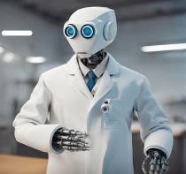

•

**Faculty of Pharmacy Alexandria University**

•

**Marketing Diploma**

•

**Quality Diploma**

•

**AI Trainer in PharmAcademy.**

•

**AI Trainer in EL**

**-**

**Sadat Academy.**

•

**AI Trainer in medical events like :**

**-**

**Mansoura University**

**-**

**Al**

**-**

**Ahram Canadian University**

**-**

**Alexandria University**

•

**Marketing Manager at Mabaret Al Nahda Hospital in Alexandria previously**

•

**Tel:**

**01010391353**



**Dr / Ayman Elkady**

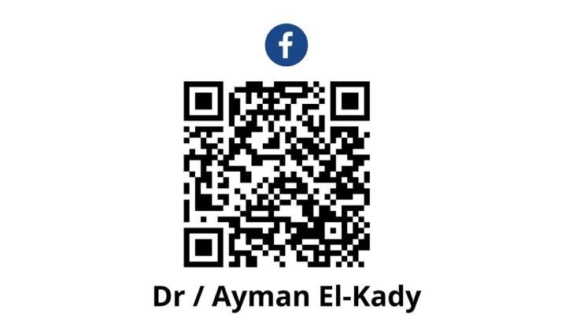

**DR_AI**

**AI In Healthcare Practice**